. Rewrite these active voice sentences into its ***passive voice*** form:

A. Marie Curie discovered radium and polonium on April 20th, 1902.

_radium and polonium___ was discovered by Mirie Curie on April 20th, 1902._____________________________________________________________________

B. My brother fixed my computer quickly.

________My computer was fixed quickly by my brother_________________________________________________________________

C. Argentina will win the next Football World Cup.

___the next Football World Cup will be won by Argentina__________________________________________________________________

D. Frank takes photos every holiday.

________Photos are taken by Frank every holiday_________________________________________________________________

E. The hurricane destroyed lots of houses.

_______lots of houses was destroyed by the hurricane__________________________________________________________________

F. Digital World designs the most popular games in the world.

______________the most popular games in the world are designed by digital world___________________________________________________________

G. Children will play football tomorrow.

________football will be played by children tomorrow_________________________________________________________________

2. ***Compare*** the following devices ***at different or the same level*** and write 6 sentences. You can use some of the adjectives below:

***Small - resistant - light - big - heavy - good - bad - colourful - expensive - cheap***

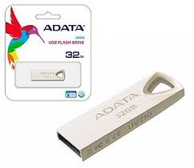

**Pendrive ADATA UV210**

Storage capacity: 32 GB

Size: 39 mm x 12.2 mm x 4.5 mm

Weight: 8.5 g

Material: aluminium

Connectivity: USB-A 2.0

Price: $699

Colours: silver or gold

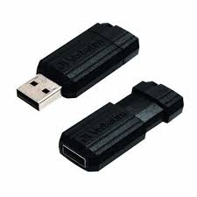

**Pendrive Verbatim Pinstripe**

Storage capacity: 64 GB

Size: 206 mm x 75 mm x 31 mm

Weight: 8.5 g

Material: plastic

Connectivity: USB-A 2.0

Price: $459

Colours: black

1. _the _Pendrive _Adata__is smaller than___verbatim._____________________________________________________
2. he _Pendrive _Adata__is more expensive than than___verbatim._______________________________________________________________
3. Storage capacity of the _Pendrive Verbatim Pinstripe is bigger than the pendrive Adata_____________________________________________________
4. __ the aluminium of the adata is more resistant than the plastic of the pendrive verbatim
5. I think that the _Pendrive Verbatim is worse than the adata_________________________________________________________
6. _he _Pendrive _Adata__is more colourlful than___verbatim._________________________________________________________________________________________________________________________________

3. Compare the devices from ex 2 to the following one and write 6 ***superlative sentences***:

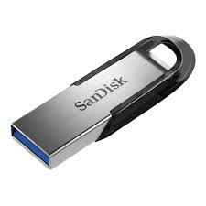

**Pendrive Sandisk Ultra Flair**

Storage capacity: 64 GB

Size: 52 mm x 10.2 mm x 30 mm

Weight: 10.2 g

Material: aluminium and plastic

Connectivity: USB-A 3.0

Price: $1200

Colours: grey

1. __the heaviest is the pendrive sandisk
2. __the least expensive is the Pendrive Verbatim Pinstripe___________________________________________________________
3. _the smallest is the pendrive data______________________________________________________________
4. _the best pendrive is the sandisk______________________________________________________________
5. _the cheaper is the pendrive verbatim______________________________________________________________
6. ___the biggest is yhe oendrive verbatim____________________________________________________________
7. _______________________________________________________________

4. ***Simple present or present continuous.*** Look at the chart and complete the sentences.

|  |  |  |  |
| --- | --- | --- | --- |
|  | **Sussy** | **John** | **You** |
| Have breakfast | never | At 7:30 am | At 9:00 |
| Play online games | At the weekends | usually | never |
| Wash the dishes | At the moment | everyday | sometimes |
| Drink a beer | now | now | On friday |

1. Sussy ____never has____________________ breakfast.
2. She ________plays onlines games__________________ at the weekends.
3. John ______has breakfast___________________ at 7:30 am everyday.
4. He ___usualluy____play online____________________ games.
5. A: _______does____ Sussy __wash________ the dishes everyday?

B: No, she __does not_________. But she is washing____________________ the dishes at the moment.

1. A: _______are______ John ___washing________ the dishes right now?

B: No, he __are not___________. But he _washes___________ the dishes everyday.

1. Sussy and John __are ______________ drinking a beer now.

5. Now complete the chart about you and write 4 sentences using ***simple present or present continuous***.

1. ____I have at breakfast at 9:00 o ‘Clock___________________________________________.
2. ____I never play online games___________________________________________.
3. ____I sometimes wash the dishes___________________________________________.
4. ____I am drinking a beer on friday___________________________________________.

6. ***Simple past or past continuous.*** Complete the sentences with the correct form of the verbs in brackets:

1. When I (eat)___ate__________ a sandwich, my husband (bring) _was bringing__________ Chinese food.
2. My brother (play) __was playing___________ football when he (injure) injured____________ his knee.
3. My computer (run) __runed__________ out of battery while I (prepare) was preparing___________ the tests.
4. While My mum (cook) was cooking_____________, the doorbell (ring) _rang_____________.
5. The teacher (deliver) __was delivering____________ a lesson when the Internet connection (fall) ______falled____ down.